**Author: George Kyeyune**

**Sserunkuuma, Bruno**

Bruno Sserunkuuma is one of the most prolific and innovative artists in Uganda today. Born in 1964, his career started during the beginning of the recovery period after Uganda’s civil war and was shaped by personal initiatives to explore local resources. Sserunkuuma noticed a gap between local pottery and his own knowledge acquired from his university training at Makerere Art School. He pursued a Masters degree in Ceramics, which he completed in 1991. Throughout his career, Sserunkuuma has investigated how local clays can be transformed into modern yet traditional pottery. Local people cloaked in colorful patterned local fashions, crowd the surfaces of his hand thrown pots, in moods of celebration and passion. Biblical scenes are translated into African context making the images part of the community in which they are placed. Hima herdsmen with their long horned cattle is another recurrent subject in Sserunkuuma’s oeuvre. On some of Sserunkuuma’s pots, he incorporates figural motifs recognisably derived from familiar Ganda material culture like mats, musical instruments and royal regalia. Sserunkuuma preserves some sense of form and texture of pottery while unhitching it from household and everyday usage. In his hands, the pot has become a new medium for a modern artist, released from the constraints of domestic tradition.

Sserunkuuma’s own history of how he became a ceramics artist is as eventful as his working process. Unable to gain admission to the schools of Medicine or Agriculture, his first and second choices at the university, he was admitted to Sciences, his third course choice. Displeased with Sciences, he changed to Fine Art, which was his fourth and final choice. Upon joining the Makerere Art School, Sserunkuuma specialised in ceramics after an abortive project in graphic design, which he had initially selected. Later Sserunkuuma’s research developed clay bodies that were suitable for a ceramist working in deprived conditions. The investigations resulted in improved clay bodies. But there was more to it. For such clay bodies Sserunkuuma also developed suitable glazes, which he called ‘over glazes’ and ‘under glazes’. These reacted variously in different temperature ranges.

Beyond considering the pot for its utilitarian value, Sserunkuuma has treated the surfaces of his ceramic ware as canvases for painting, expressing himself in a painterly form. However, the nature of his colors is such that they do not blend into each other. They can only be applied in flat layers. Bruno capitalizes on this decorative aspect to create an overall visual impact of color pattern rather than elaborate detailed compositions.

Depending on where they are sourced, colors and textures in Uganda clay vary considerably and they provide Sserunkuuma with the opportunity for a wide range of selection. In the case of decorative colours, Sserunkuuma experimented with earth colours he obtained from slips (liquid clays) together with imported oxides. To this assortment, he has added anthill soil. With these materials he decorated his pots with motifs derived from local subject matter, patterns and textures. Engombe decoration is another of Sserunkuuma’s adaptations from local pottery that employs color slips applied on white background in parts. Over this surface, Sserunkuuma scratches out figural motifs, a technique he calls *graffito.*

**References and Further reading**

Alliance Francaisede Kampala in partnership with Makerere School of Industrial and Fine Arts Catalogue (2000) *Ceramics by Bruno Sserunkuuma*.

Breitinger, E. et al.(1999) *Uganda; The Cultural landscape*. Kampala Uganda: Fountain Publishers.

Calder, A. (2000) “Uganda’s Modern Art Movement”, *Ijele.* Art Journal of the African World, Vol.1, No. 2.

Deliss, C. et al. (1995) *Seven Stories about Modern Art in Africa.* London: White Chapel Art Gallery.

**Ingham,** K. (1958) *The Making of Modern Uganda*. London: George Allen and Unwin Ltd;.

Kingdon, J. (1973) Makerere Art Gallery Catalogue. School of Fine Art Makerere University   
n.d: *Mkomazi Mind and Memory Maps* . Royal Geographical Society  
-(1962) “Reflections” *Transition.* Vol. 2, No. 6 and 7, October  
-(1962) “Murals of Fort Hall Chapel”. *ROHO,* Vol. II: School of Fine Art, Makerere College.  
-(1995) “Makerere Art School”, Interview with Wanjiku Nyachae in Deliss *et al, Seven Stories about Modern Art in Africa.* London: White Chapel Art Gallery

Kyeyune, G.  
-(2001) *L’art modern a l’university de Makerere Ouganda*, Antholgie de l’art Africain du Xxe Siecle. Paris: Editions Revue Noire, pp. 192-194.  
-(2002) *“Uganda’s Visual Environment”* in Action and Vision: Painting and Sculpture in Ethiopia, Kenya and Uganda from 1980. Edited by John Picton, E. Court and R. Loder, London: The Triangle Trust, pp 43-48.

Kasfir**, S. L.** (1999) *Contemporary African Art* , London: Thames and Hudson Ltd.

**Unpublished Literature**

Kyeyune, G.(2003) *Art in Uganda in the 20th Century***:** PhD thesis, School of Oriental and African Studies University of London

Sunanda S. (2000) *Imaging Art, Making History: Two Generations of Makerere Art*, PhD thesis Emory University, Atlanta-Georgia

KakandeA. (2008) *Contemporary Art in Uganda*: *a nexus between Art and politics:* PhD thesis, University of Witwatersrand, Johannesburg.

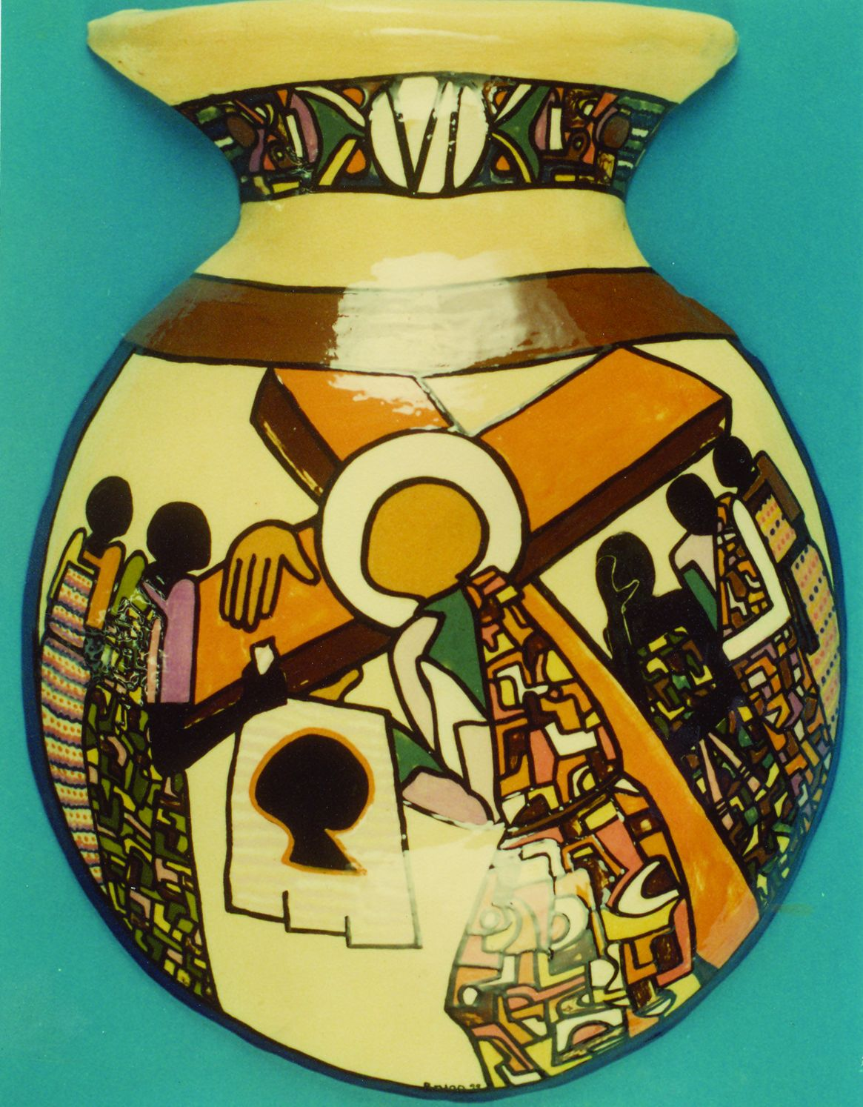

Stations of the Cross-- 2X2.5 ft photo copyright George Kyeyune (photo taken in 2002)

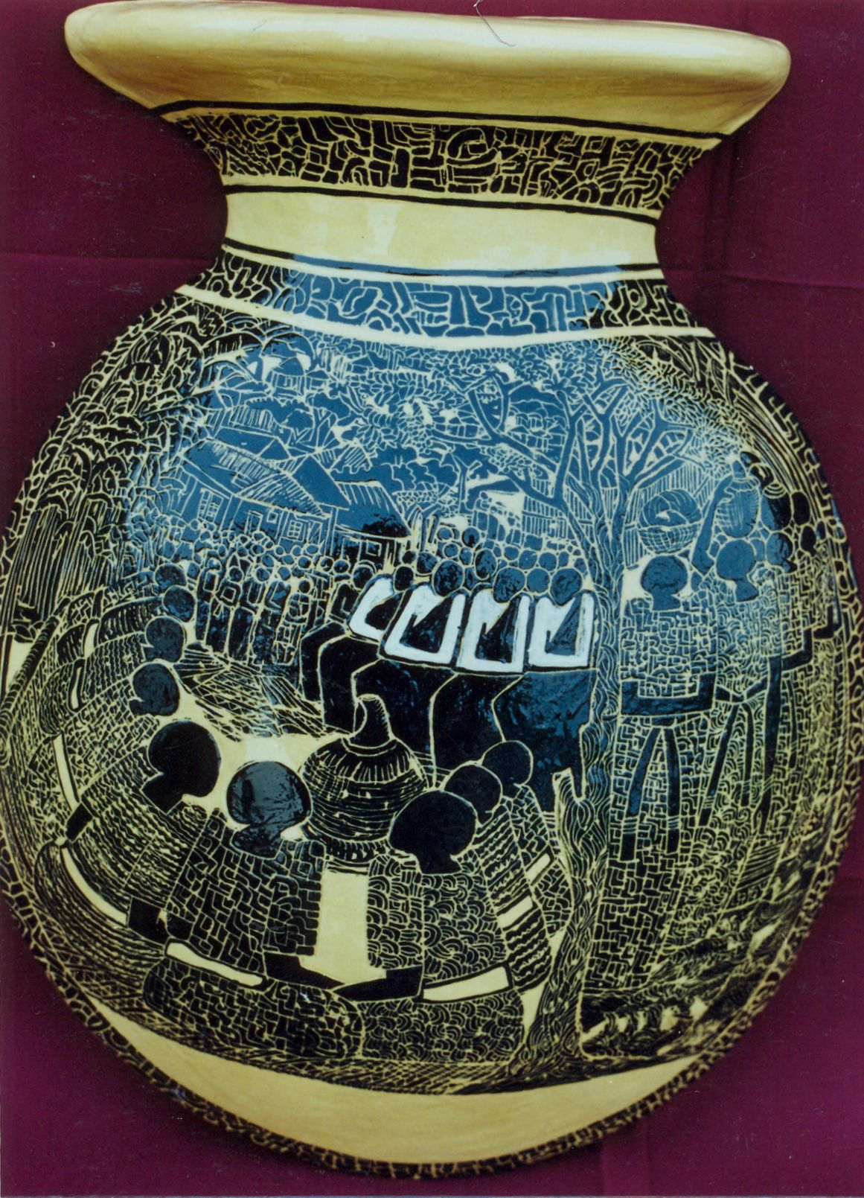

Okwanjula  2X2.5 ft  Photo copyright George Kyeyune (photo taken in 2004)